**Build your first SharePoint client-side web part**

Client-side web parts are client-side components that run inside the context of a SharePoint page. Client-side web parts can be deployed to SharePoint Online, and you can also use modern JavaScript tools and libraries to build them.

1. To create a new web part project

* Create a new project directory in your favourite location.
* Open command prompt
  + Run as administrator

*md Demo-webpart*

1. Go to the project directory

*cd Demo-webpart*

1. Create a new Demo web part by running the Yeoman SharePoint Generator.

yo @microsoft/sharepoint

**When prompted**:

* Accept the default **demo-webpart** as your solution name, and then select Enter.
* Select SharePoint Online only (latest) and select Enter.
* Select Use the current folder for where to place the files.
* Select N to not allow the solution to be deployed to all sites immediately.
* Select N on the question if solution contains unique permissions.
* Select WebPart as the client-side component type to be created.

**The next set of prompts ask for specific information about your web part:**

* Accept the default HelloWorld as your web part name, and then select Enter.
* Accept the default HelloWorld description as your web part description, and then select Enter.
* Accept the default No JavaScript web framework as the framework you would like to use, and then select Enter

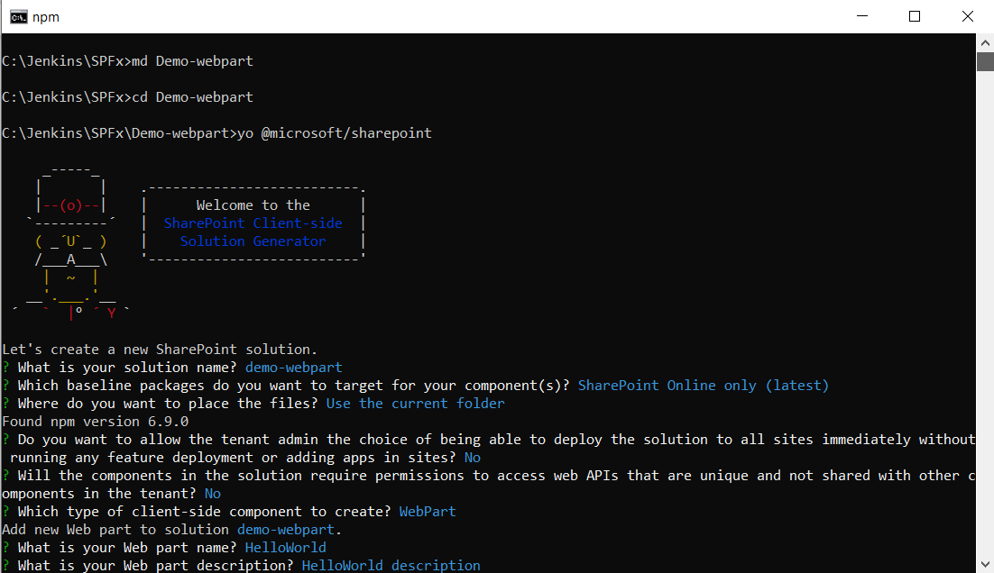

At this point, Yeoman installs the required dependencies and scaffolds the solution files along with the HelloWorld web part. This might take a few minutes.

When the scaffold is complete, you should see the following message indicating a successful scaffold.

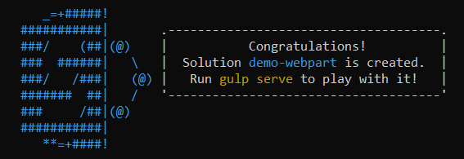

**Preview the web part**

To preview your web part, build and run it on a local web server. The client-side toolchain uses HTTPS endpoint by default. This setting can be configured in the serve.json file located in the config folder, but we do recommend using the default values.

Switch to your console, ensure that you are still in the Demo-webpart directory, and then enter the following command:

gulp trust-dev-cert

**Note:**

*Developer certificate has to be installed ONLY once in your development environment, so you can skip this step, if you have already executed that in your environment.*

**gulp serve**

This command executes a series of gulp tasks to create a local, node-based HTTPS server on localhost:4321 and localhost:5432. The workbench is then launched in your default browser to preview web parts from your local dev environment.